1. Install Windows 10 Update 21H2. If it does not work through the update center, then follow the instructions <https://www.comss.ru/page.php?id=9317>
2. Enable Intel Virtualization Technology in Bios: **Advanced > CPU Configuration > Intel Virtualization Technology**
3. Install wslv2 <https://docs.microsoft.com/ru-ru/windows/wsl/install>

run these commands in Microsoft PowerShell, it should install version 20.04 by default:

wsl --install -d -ubuntu

wsl --set-version ubuntu 2

1. Open ubuntu and update available packages:

sudo apt-get update

sudo apt-get dist-upgrade

1. Install ROS <http://wiki.ros.org/Installation/Ubuntu>

In 1.4 Installation choose “Desktop Install”, to then manually select the version of gazebo

1. Before installing Gazebo, you need to install VcXrvc for GUI output <https://sourceforge.net/projects/vcxsrv/>

Set Display number to 0

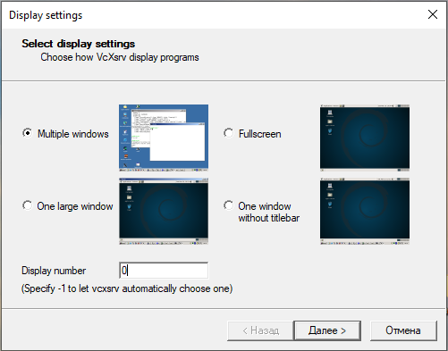

In the last window, put "Disable access control"

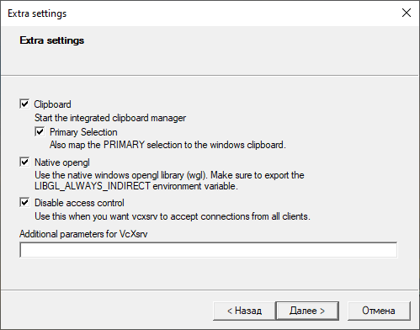

1. Install Gazebo <https://classic.gazebosim.org/tutorials?tut=install_ubuntu&cat=install>

Before starting Gazebo, you need to change the display output. To do this, enter your IP address.

**Start > Settings > Network & Internet > Ethernet > your network connection > IPv4**

export DISPLAY=<Your IPv4 Address>:0.0

export GAZEBO_IP=127.0.0.1

export LIBGL_ALWAYS_INDIRECT=0

After that, start Gazebo, a connection to the server will appear and the Gazebo window will open



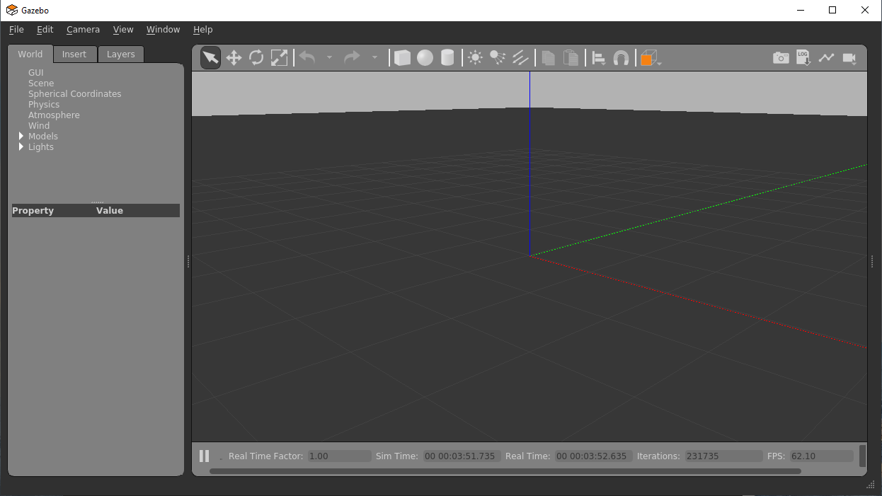

If it doesn't, try

gazebo --verbose

If there are no errors and everything is green, but there is no connection to the server, then double-check the IP address

1. Then you can install gazebo_ros, choose ros noetic. <https://classic.gazebosim.org/tutorials?tut=ros_installing&cat=connect_ros>

should run without problems:

roscore & rosrun gazebo_ros gazebo

1. Install MAVROS

<https://ardupilot.org/dev/docs/ros-install.html#installing-mavros>

1. Copy and install via github ArduPilot

<https://ardupilot.org/dev/docs/building-setup-linux.html#building-setup-linux>

1. You will also need to execute the file to install the library

./install_geographiclib_datasets.sh

1. In the end, it will be possible to connect Ardupilot to ROS

<https://ardupilot.org/dev/docs/ros-sitl.html>

